Indholdsfortegnelse

SQL 1

Installing Windows server 2012: 1

I installed MS SQL 2014: 2

Sql server configuration manager: 2

Database TEC: 2

Adding Keys: 3

The purpose of keys 4

Working plan: 4

05-09-2018 4

06-09-1018 4

07-09-1018 5

Conclusion 5

# SQL

**Introduction**

The project is about building a database that contains all of the personal information of students and teachers that goes to a same school the database contains data in a certain data type and it contains in an online server so it will be easy to access the authorized people and can make developments. (**all of the data is computerized )**

## Installing Windows server 2012:

When installing server, I chose to install windows sever 2012(GUI) and I add 3 users to the server called user1,user2 and user 3. After that I installed Framework 3.5 R1 and then I installed MS SQL 2014.

## I installed MS SQL 2014:

After installing I installed MS SQL 2014, I add some firewall rules. I add program rule type and port rule type.

### Sql server configuration manager:

I checked if my server and sever browser is up and running and enable all the protocols for SQLEXPRESS

## Database TEC:

Database TEC contains tables named [Elev],[ PostNrBy],[Laerer],[Klasse]

**Elev:**

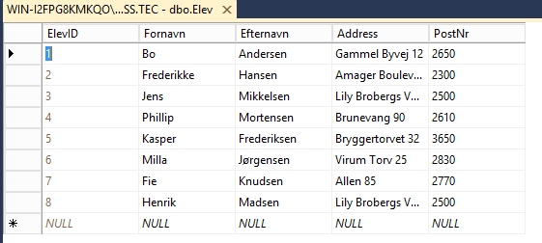

**PostNrBy table:**

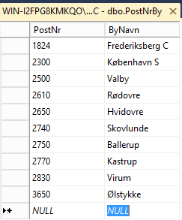

**Lære table:**

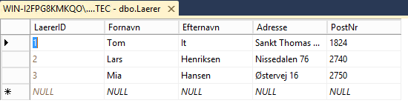

**Klasse:**

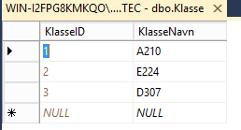

## Adding Keys:

Make a relationship between data bases by adding primary keys and foreign keys

• Elev tabellen:

* Primary key: ElevID
* Foreign key: PostNr
* References: PostNr

• PostNrBy tabellen:

* Primary key: PostNr

• Laerer tabellen:

* Primary key: LaererID
* Foreign key: PostNr
* References: PostNr
* Foreign key(2): LaererID
* References(2): KlasseID

• Klasse tabellen:

* Primary key: KlasseID

## The purpose of keys

The Job table definition includes a primary key and a foreign key. A primary key is a column or group of columns that uniquely identify a row. A foreign key is a column or set of columns in one table whose values must have matching values in the primary key of another (or the same) table.

# Working plan:

## 05-09-2018

Installed windows server 2012, the Framework 3.5 R1, windows SQL adds the user accounts.

## 06-09-1018

Started creating the data base, and make the tables and create a relationship.

## 07-09-1018

Finished the project by making the if statement so it can run over and over again without over lapping with exist data

## Conclusion

Learnt how to build a database independently so it will be helpful in the future when I’m building my own privet projects. I have now learnt how to build a database for my upcoming projects.